●Name:

Xindi Liu

●Hometown:

Huaibei City, Anhui Province, China

●A recent picture of yourself or digital avatar:

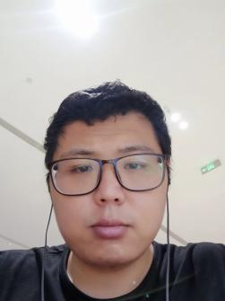

●Social handle or URL:

Email: dylanliuofficial@gmail.com

Kaggle: <https://www.kaggle.com/dylanliuofficial>

Upwork: <https://www.upwork.com/freelancers/~01b5eb8adbab160ae5>